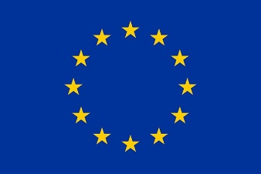

This project has received funding from the European Union’s Horizon 2020
research and innovation programme under grant agreement No 731996
Annex 7 TO REQUEST FOR TENDERS
Statement of joint and several liability
Codice CIG n. 75400928C0

Applicable to the “Smart.met” project as referred to the action entitled ‘PCP for Water Smart Metering — SMART.MET as described in the Grant Agreement No 731996 associated with document Ref. Ares(2016)6330258 - 09/11/2016 available on the EU Commission participant portal

Annex 7 Statement of joint and several liability

This Statement only needs to be added to the proposal if the Tenderer is consisting of a grouping of companies (Consortium).
Groupings of companies (Consortia) may participate in this PCP tender procedure, provided that their participation is in accordance with the principles of EU and applicable national competition law.
In this Statement of joint and several liability, the Consortium members conform to the following requirements:
- Each member of the Consortium hereby agrees to appoint the lead contractor as mentioned below to operate as single point of contact to the Lead Procurer
- Each member of the Consortium hereby authorizes the lead contractor to act in its name and on its behalf, concerning their rights and obligations under the Framework Agreement and Phase 1 Contract, and to sign the Framework Agreement and the Phase 1 Contract on their behalf;
- Each member of the Consortium hereby accept joint and several liability for all obligations of the contractor under the Framework Agreement and Phase 1 Contract
- Each member of the Consortium is listed in the professional register or trade register or a foreign equivalent in accordance with the legislation in force in the country where it is established;

Member of the Consortium 1 (lead contractor and authorized to act in the name and on behalf of the Consortium)

Name of duly authorized person
Function
Signature
Place and date
Activities / expertise of the member in the Smart.Met PCP Project

Member of the Consortium 2

Name of duly authorized person
Function
Signature
Place and date
Activities / expertise of the member in the Smart.Met PCP Project

Member of the Consortium 3

Name of duly authorized person
Function
Signature
Place and date
Activities / expertise of the member in the Smart.Met PCP Project

Member of the Consortium 4

Name of duly authorized person
Function
Signature
Place and date
Activities / expertise of the member in the Smart.Met PCP Project

Member of the Consortium 5

Name of duly authorized person
Function
Signature
Place and date
Activities / expertise of the member in the Smart.Met PCP Project

